ALT MOBILITY SQL QUERIES:-
- ORDER TABLE
- Order Status Distribution
select order_status, count(*) as Total_Order from customer_orders
group by order_status;

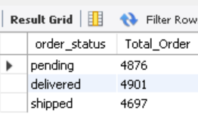
- Monthly Sales Trend
Select date_format(order_date, '%Y-%M') as Montly_Sales,
sum(order_amount) as total_sales
from customer_orders
group by Montly_Sales
order by Montly_Sales;

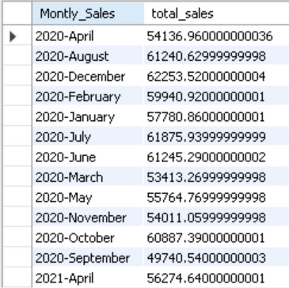

3. Revenue by Order Status

Select order_status,Sum(order_amount) as Total_Revenue
from customer_orders
group by order_status;

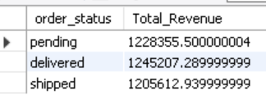
- Customer who placed more than one order

Select customer_id, count(order_id) as Total_Orders
from customer_orders
group by customer_id
having count(order_id) > 1 ;

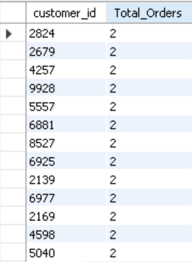

- Customer Segmentation by Total Spend

SELECT customer_id, SUM(order_amount) AS total_spent,
CASE
WHEN SUM(order_amount) >= 1000 THEN 'High Value'
WHEN SUM(order_amount) BETWEEN 500 AND 999 THEN 'Medium Value'
ELSE 'Low Value'
END AS customer_segment
FROM
customer_orders
GROUP BY
customer_id;

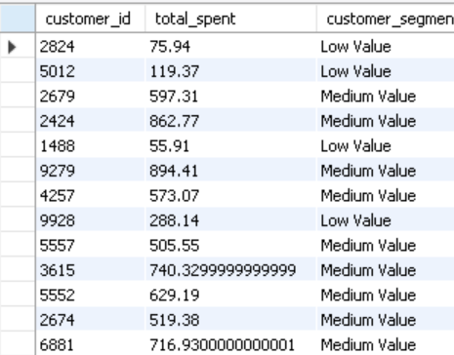

- Customer Order Trends Over Time

SELECT
customer_id,
DATE_FORMAT(order_date, '%Y-%m') AS Month_Sales,
COUNT(order_id) AS orders_placed,
SUM(order_amount) AS total_spent
FROM
customer_orders
GROUP BY
customer_id, Month_Sales
ORDER BY customer_id, Month_Sales;

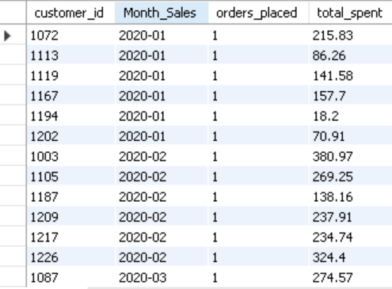

- Payment Status Summary:-

- Payment Status

SELECT payment_status,
COUNT(*) AS total_payments
FROM payments
GROUP BY payment_status;
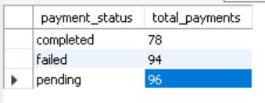

- Payment Failure Rate
SELECT ROUND(SUM(CASE WHEN payment_status = 'failed' THEN 1 ELSE 0 END) * 100.0 / COUNT(*),2) AS failure_rate_percentage
FROM payments;

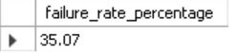

- Payment Method by Status

SELECT payment_method,payment_status,COUNT(*) AS count
FROM payments
GROUP BY payment_method, payment_status
ORDER BY payment_method, payment_status;

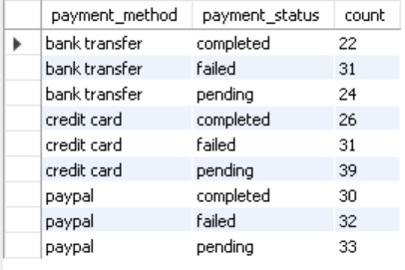

- Comprehensive Order Details Report

SELECT
o.order_id,
o.customer_id,
o.order_date,
o.order_status,
o.order_amount,
p.payment_id,
p.payment_date,
p.payment_amount,
p.payment_method,
p.payment_status
FROM customer_orders o
LEFT JOIN payments p
ON o.order_id = p.order_id
ORDER BY
o.order_date DESC;

